Job Interview Worksheets

The Resource Center

Materials contained in this handout are excerpted from:

The Successful Job Interview

Permission is granted to make one copy for each student in the classroom.
Any other use is prohibited and protected by copyright law.

Available from:
The Resource Center www.RCTresources.com

Contents Copyright 2004, The Resource Center for Technology, Inc.


}OB OB}ECTIVE WORKSHEET

The questions below can help you determine what your job objectives should state: what type of employment you are seeking; what you can o(fer the company; where you want to go with this position.

Answer these questions, and write a job objective based on your answers.

What kind of job would I like to have* Three choices would be:
job 1
job 2
job 5

What qualifications do I have for the jobs I listed above*
job 1
job 2
job 3

What can I do to be better qualified for these jobs*
Iob l job 2
job 5

What are my future goals in these positions?
Job l Job 2
Job 5

EDUCATION WORKSHEET

-‹

Use your answers to the following questions to compile information for Education Data on your résumé.

List courses you have taken in high school, vocational school, and college.

Which of these courses have helped you prepare for the position you want*

In which of these courses have you excelled?


COVER LETTER WORKSHEET

Answering the questions below will help you decide what information should be included in a cover letter.

What do I want from this company*

What can I offer this company*

What experience do I have that will qualify me for this position*



Choose advertisements from your local paper for three different positions you would like to have. Write a cover letter for each of these positions. Have a friend or class- mate critique your letters for clarity, conciseness, and positive wording. Ask them how your lenes can be improved.

PERSOXAL
APPLICATION FOR E¥4PLOYHENT

Name Social Security #

i-ast
First 1 liddle

Street Address Phone City State Zip Code If less than one year, previous address Type of employment desired: Permanent Temporary Full-time Part-time
Position desired
EDUCATIOX

School Name and Address
Dates Attended
From - To De ee Maior

ACTIVITIES
List honorary, social, athletic activities. Do not list activlties which indicate race, creed, color, national origin, or religious affiliation.

EXPERIENCE
List all previous employment, beginning with your most recent position.
Company Name and Address Type of Business Your Position Supervisor’s Name and Tide

Length of Employment: From To
Salary: Start End

Duties Reason for Leaving
Company Name and Address Type of Business Your Position Supervisor’s Name and Title Length of Employment: From To Salary: Start End
Duties Reason for Leaving
Company Name and Address Type of Business Your Position Supervisor’s l4ame and Title Length of Employment: From To 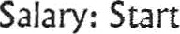 End
Duties
Reason for Leaving

APPLICATION FOR EMPLOYI"¥ENT
Please PRINT in ink and complete ALL information.

Name Date
Current Address Phone
City State Zip How long* Previous Address Social Security Number U.S. Citizen Yes Mo Type of Work Desired Dateyoucanst3rt

EXPERIENCE Reason for
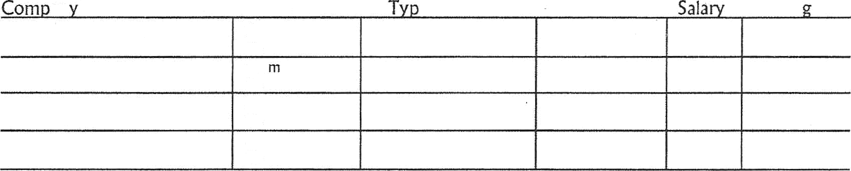
an Name/Address
Dates
e of Business
Duties
Leavin
To
Fro
To

To From To

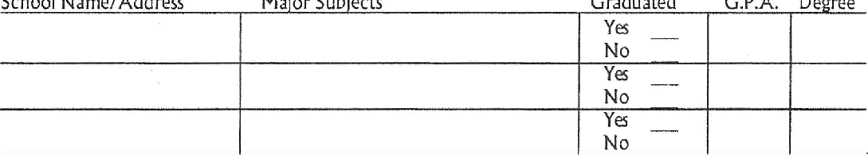EDUCATION
School Name/Address
Ma’or Sub‘ects
Graduated
Ya No Ya No
G.P.A. De ree
Mo

ACTIVITIES
School Act'vities (indicate high school or college)

Professional Activities

Do you have any relatives or friends emp1oyed at his company at present* If yes, give name, relationship, and division of employment

Have you ever worked for this company or any of its subsidiaries* If yes, give date and name/location of division last worked

NOTE: Before signing the following xatement, please review this appliCation to make cenain that you have answered all the questions that apply to you.

I declare that this application presents, to the best of my knowledge, an accurate statement of facts, and I have no objection to the company’s conducting such investigation of these facts as it may deem advisable. This authorization sha!I be valid for one year from this date.

Applicant’s signature Date

Practice Interview Questions

What can you tell me about yourself?

Why do you want to work for this company? Why have you chosen this field as your career? Why did you leave your last job?
What salary do you expect?

What are your career objectives five years from now? Ten years from now? What do you feel your strong points are? Your weak points?
Which courses did you enjoy most in school?

Have you had trouble with any courses in school? Why? How would you describe yourself?
How has your education prepared you for this position? How do you define success?
In what way do you think you can make a contribution to this company?

What type of relationship do you feel should exist between a supervisor and subordinates? What was your most rewarding experience during school?
Do you have plans to continue your education?

What have you gained from your extracurricular activities/

Are you more comfortable working in a large group or with just a few people? How do you think you work under pressure?
What do you know about this company/job?

What do you feel is the most important aspect of a job? Are you willing to relocate? Travel? Work overtime?
How do you spend your spare time?

How well do you get along with other people?

Why should I hire you?

Have you ever had a conflict at work? How did you handle this conflict? What do you think about your previous manager?
How do you feel about supervision?


INTERVIEW RATING SHEET


Listed below are some qualities used to rate potential emp(oyees during an interview. After practicing an interview, how do you think you rate on these*

Above Average | Average | Below Average
5 | 3 | i

Ability to Talk
Aggressiveness
Appearance
Counesy
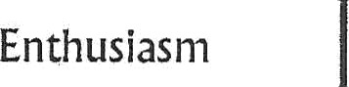
Intelligence
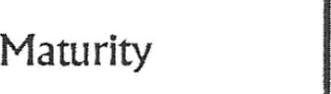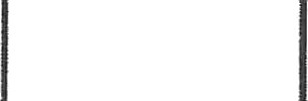
Personality
PoUe


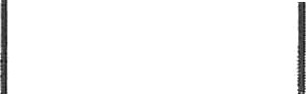Using the values given under each category, add the score for your answers and determine your rating on the following scale:

Z6 - 45 Ready for the interview

27 - 35 Might handle it; could USe more practice 9 - 26 Definitely need more practice

SUH¥€AkY

To Do Or Xot To Do. That Is The Difference

DO
B Prepare a complete, attractive resume that stresses your qualifications in a
positive manner.
D Get permission from people you plan to use as references. B Write an effective cover letter that really sells “you.”
B Fill out the application completely, accurately, and legibly.
a use the completed résunié as a reference for filling out the application. Al Arrive for the interview a few minutes early.
D Dress appropriately for the interview.
B Go to the interview alone.
B Bring résumé, social security card, work permits and licenses to the interview.
B Greet the receptionist and the interviewer courteously. tz Present yourself with confidence.
B Research the company.
fz Be prepared to answer questions about yourself and your qualifications. B Be prepared to ask questions about the company.
B Smile.
fz Follow the interview with a thank-you letter.

DO NOT

- Do not present a résumé that was hastily put together or has typographical
errors and smudges.
IN Do not use a general, all-purpose résumé.
El Do not give inaccurate information.
IN Do not present an application that is unreadable or incomplete.
IN Do not arrive late for an interview.
Do not wear jeans, wrinkled clothing, or outrageous jewelry to an interview.
@ Do not overdo perfume or aftershave.
Do not take friends or family to an interview.
IN Do not act as if the receptionist and interviewer are doing themselves a favor by seeing you.
@ Do rot forget your manners.

XOST CO1"¥HON REASONS WHY PEOPLE ARE NOT HIRED

Bad personal appearance Too aggressive
Unable to express self clearly Poor interest and enthusiasm  No career planning, no goals
Overly nervous, under confident Too much emphasis on money
Not willing to start at the bottom
Discourteous
o Immature
 Speaks ill of former employers
Cannot make eye contact with interviewer
Messy application form
Late arrival for interview
Did not show appreciation for interviewer’s time
Asked no questions about the company
Could not give direct answers when questioned

